# **Sir Syed University of Engineering & Technology (SSUET)**

# **Software Engineering Department**

***Course Name: Software Construction & Development (SWE-312)***

***Semester: 5th***

***Batch: 2020***

***Section:***

**PROJECT REPORT**

***Project Title: University Admission and Management System***



***Submitted By: Submitted To:***

Shehryar Akram(2020-SE-055) Mam Sitwat

Abdul Rafay(2020-SE-067) Sir Saad

Aneeq Uddin(2020-SE-069)

Utaib Masharib(2020-SE-093)

**TABLE OF CONTENTS**

|  |  |  |
| --- | --- | --- |
| 1 | PROJECT DESCRIPTION | 04 |
| 2 | CLASS DIAGRAM | 05 |
| 3 | THREAD SYNCHRONIZATION IN YOUR PROJECT | 6-9 |
| 4 | CONCEPT OF MUTABILITY AND IMMUTABILITY IN YOUR PROJECT | 10-11 |
| 5 | EXCEPTION HANDLING IN YOUR PROJECT | 12-13 |
| 6 | URL OF YOUR GITHUB PROJECT REPOSITORY | 13 |
| 7 | USER GUIDE | 14-15 |
| 8 | REFERENCES | 16 |

TEAM PROFILE

1. **Shaharyar Akram (2020-SE-055)**

(He Gathered all the Project Information and had done Project Description Class Diagram in the report)

1. **Abdul Rafay (2020-SE-067)**

(He implemented the Code and performed Thread Synchronization and User Guide in the project)

1. **Aneeq Uddin (2020-SE-069)**

(He Gathered information of the project and performed the concept of Mutability and Immutability in Your Project)

1. **Utaib Masharib (2020-SE-093)**

(He implemented the GUI of the project and also perform Exceptional Handling and attach the URL of the GitHub)

## 1. PROJECT DESCRIPTION

UNIVERSITY ADMISSION and MANAGEMENT SYSTEM(UAMS) deals with the admission criteria of a student and furthermore we have maintenance of university members (faculty, student) information within the university. It is an automation system, which is used to store the college, faculty, student, courses and information of a college. Starting from registration of a new student in the university, it maintains all the details regarding the attendance and marks of the students. The project deals with retrieval of information through an INTRANET based campus wide portal. It collects related information from all the departments of an organization and maintains files, which are used to generate reports in various forms to measure individual and overall performance of the student. And we have also added some features that can help in calculation and to write some details.

## 2. CLASS DIAGRAM

|  |
| --- |
|  |

## 3. THREAD SYNCHRONIZATION IN YOUR PROJECT

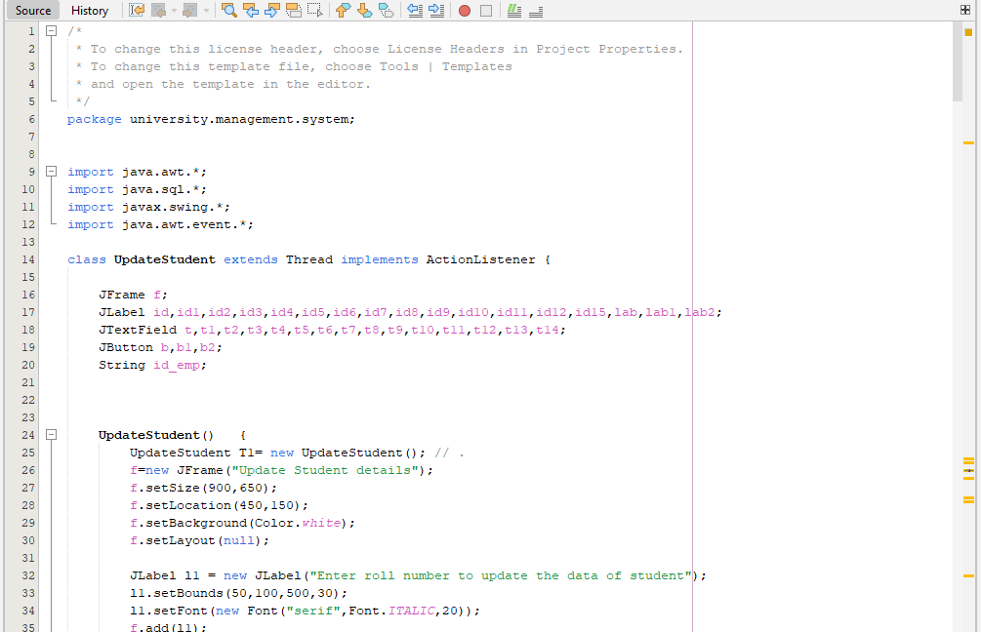

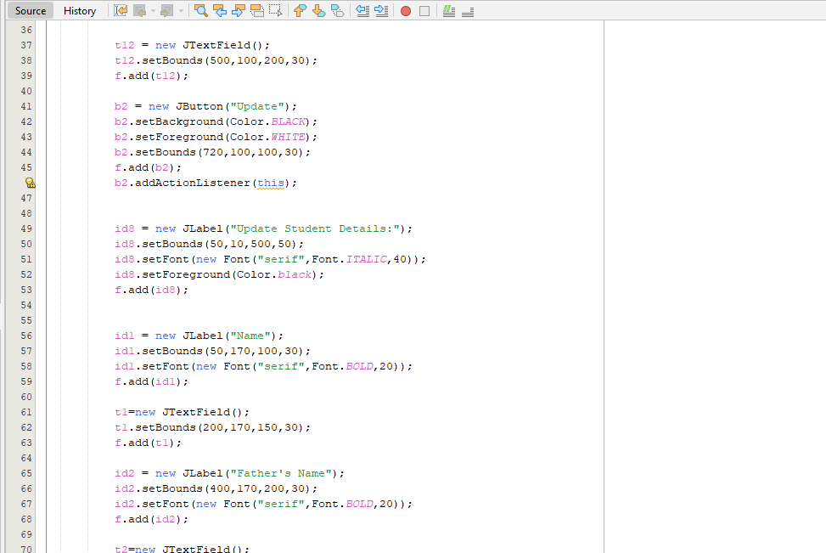

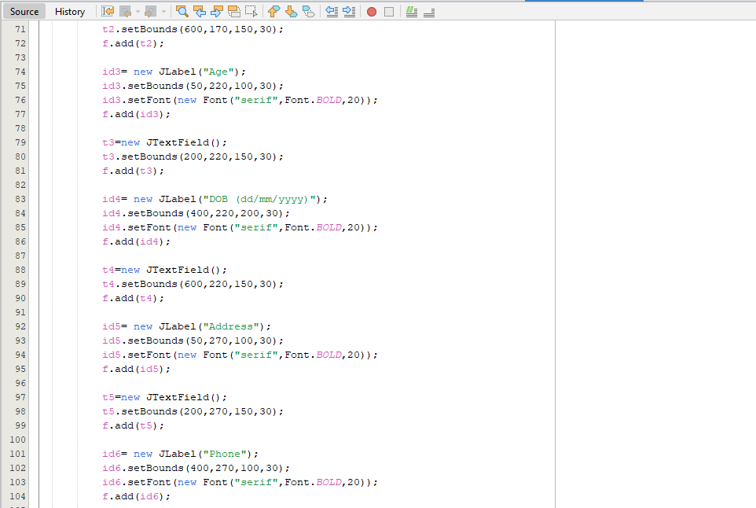

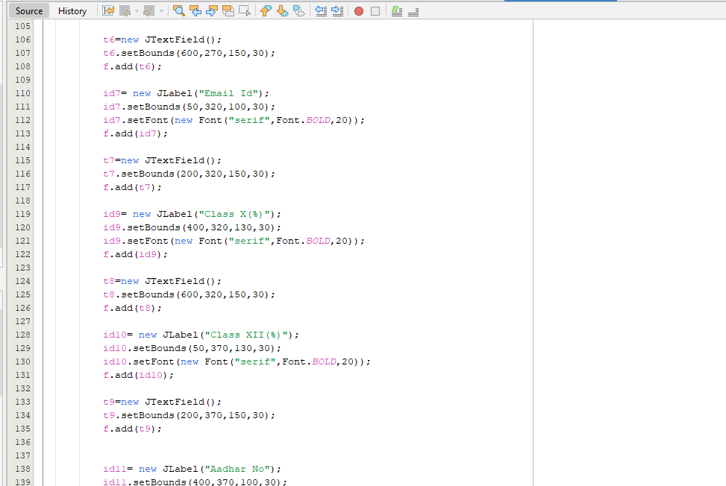

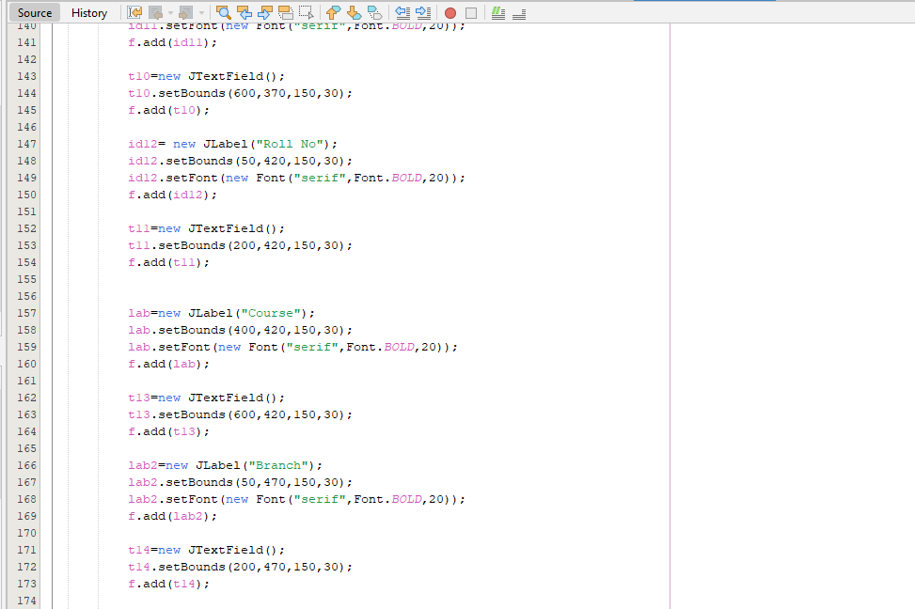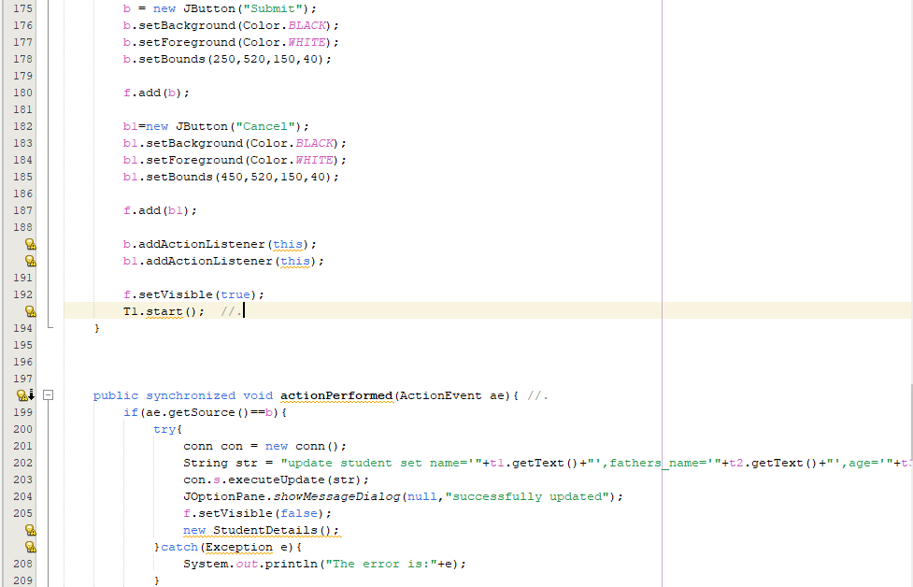

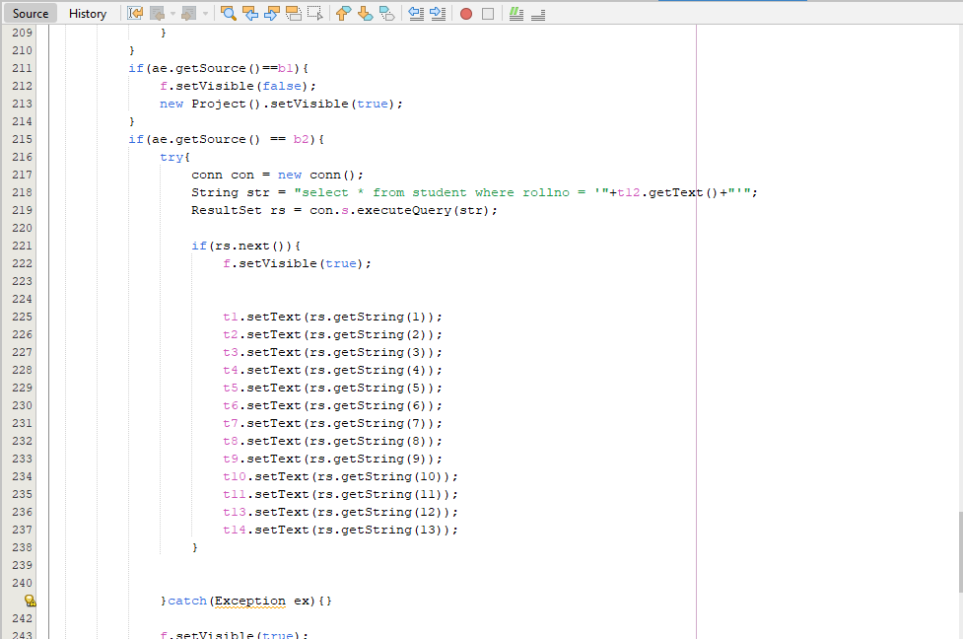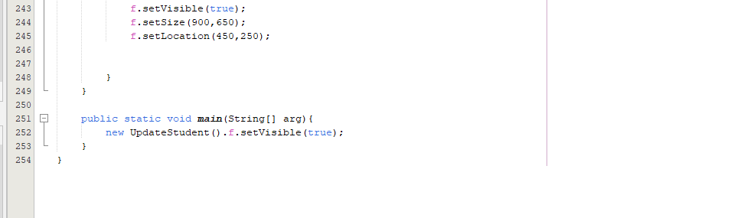

## 4. CONCEPT OF MUTABILITY AND IMMUTABILITY IN YOUR PROJECT

**Mutability:**

|  |
| --- |
|  |

**Immutability:**

|  |
| --- |
|  |

## 5. EXCEPTION HANDLING IN YOUR PROJECT

* **Login:**

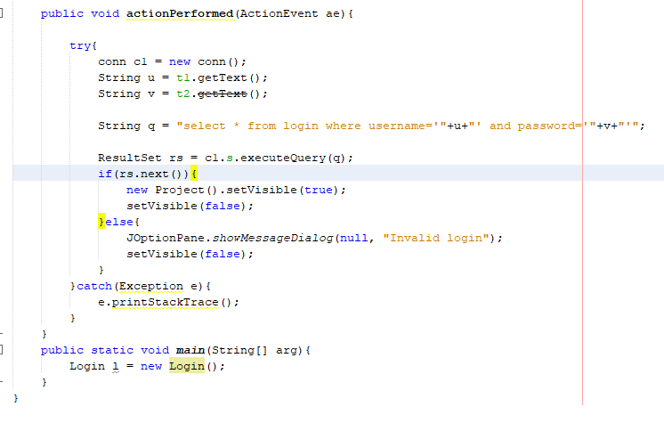

* 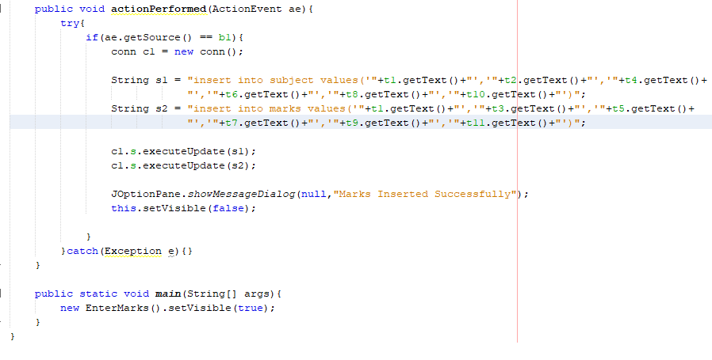**EnterMarks:**
* 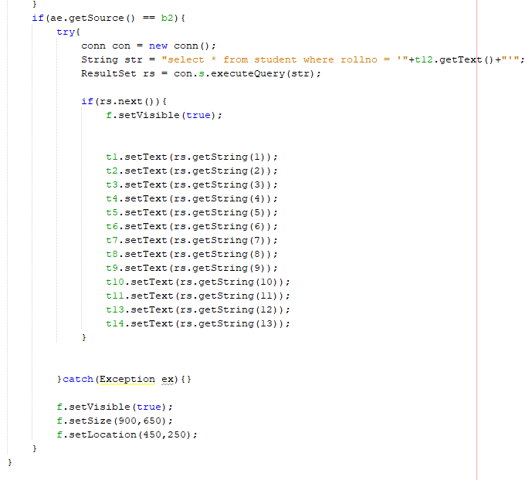**UpdateStudent:**

## 6. URL OF YOUR GITHUB PROJECT REPOSITORY

* https://github.com/utaibmasharib1/university-admission-and-management-system

## 7. USER GUIDE

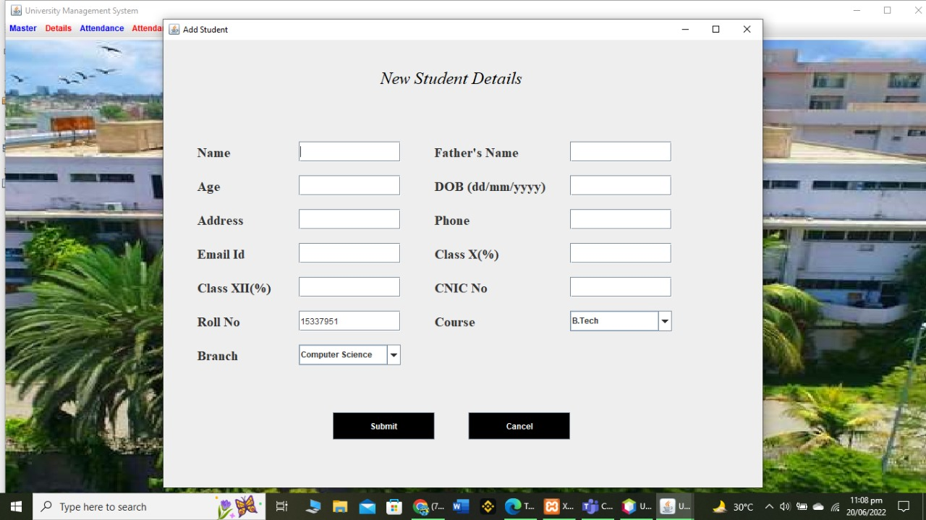In this Project Student required to login the page via using username and password (admin). If the Username and password matched from the required database so it will login to another page. The student can fill the admission form in which he needs to fill the Name, Father Name, Age, DOB, Address, Contact Number, Email Address, Matric and Inter Percentage, CNIC Number and field. And the system will assign a “ROLL NO” to the student.

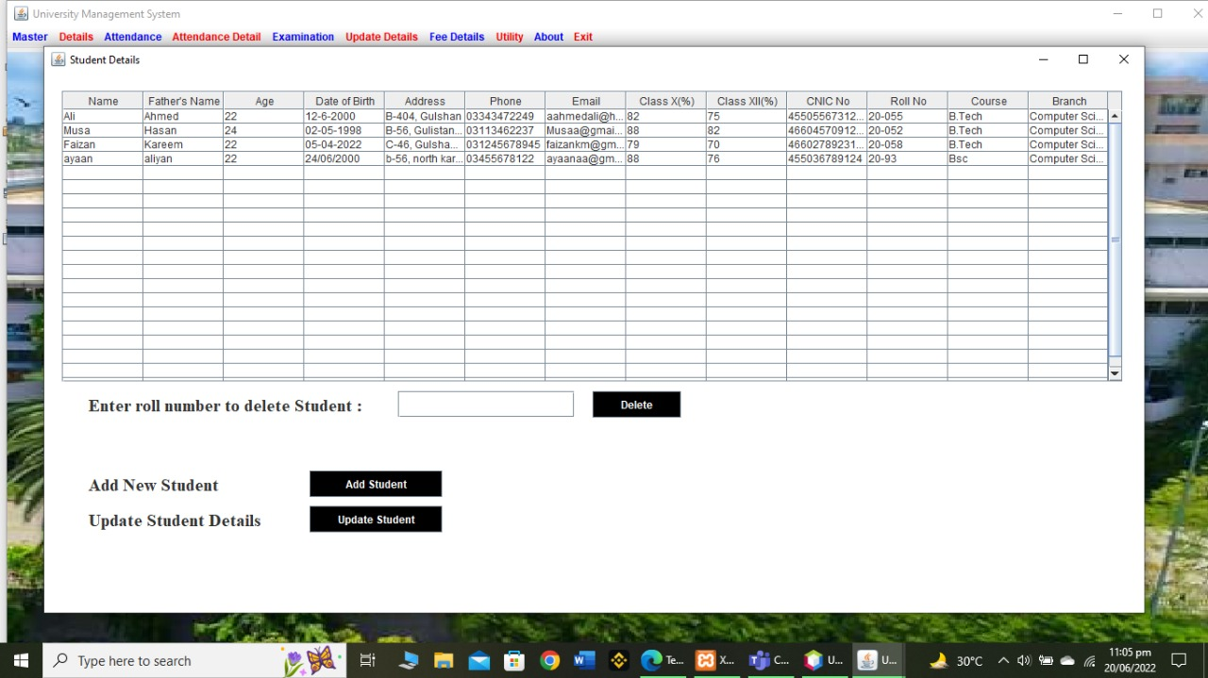Student record will be saved in university records.

We can also update the student record later if anything changes.

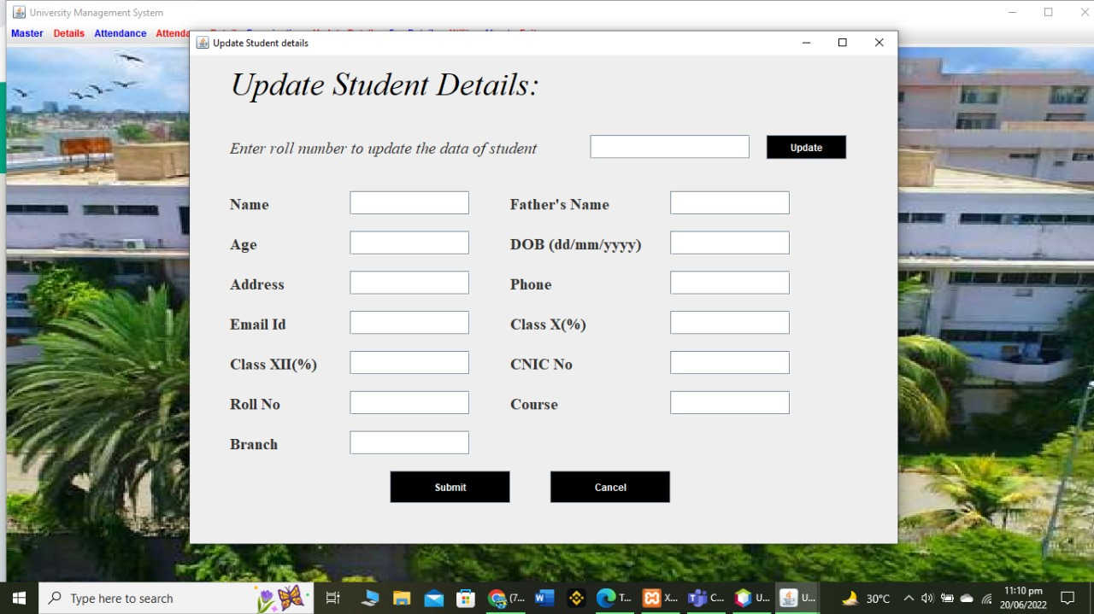

References:

* <https://www.youtube.com/watch?v=Kmgo00avvEw>
* <https://www.youtube.com/watch?v=UppFRatTTzs>
* <https://www.youtube.com/watch?v=-2_P4zJTiog>